SUPERVISION
Date / time: 09/10/2025

Main issues discussed
- Ethics Application vs Research Proposal. The ethics application is only for review and approval and is not marked. Ethics approval does not mean the proposal has passed, and vice versa. My supervisor has already approved my ethics application.
- Deadlines, grace periods, and extensions: there are only three working days left before the proposal deadline, and my supervisor can provide feedback on Monday. The technical grace period is 24 hours. An extension can provide an extra five days, but evidence is required and it usually needs to be requested two weeks before the deadline.
- specific suggestions for the Gantt chart. This is very useful and can be created in Excel or Word. The idea is to place the timeline at the top, with key tasks below, and present only the most important items in a simplified way.
- readability and audience. Maximize accessibility: even specialized research should be understandable to a layperson in its broad strokes. Define or explain technical terms on first use, striking a careful balance between readability and information density.
- Structure and Essential Content of the Proposal. My current proposal is more like a completed dissertation than a proposal, so it needs to be simplified. A good proposal should be easy to understand, have a clear plan, and provide clear justifications.
Many procedural and methodological details can be deferred to subsequent projects; there is no need to expand on them in the proposal. Instead, the proposal must focus on the essentials: a clear title, a well-defined research objective/motivation, and a structured plan.
The literature review should map out the state-of-the-art (SOTA) in the field—what experts have accomplished and what is currently known—while identifying remaining unresolved questions or knowledge gaps. This prevents duplicating existing work and allows you to align your research directly with these gaps, highlighting both its necessity and its innovative contribution.
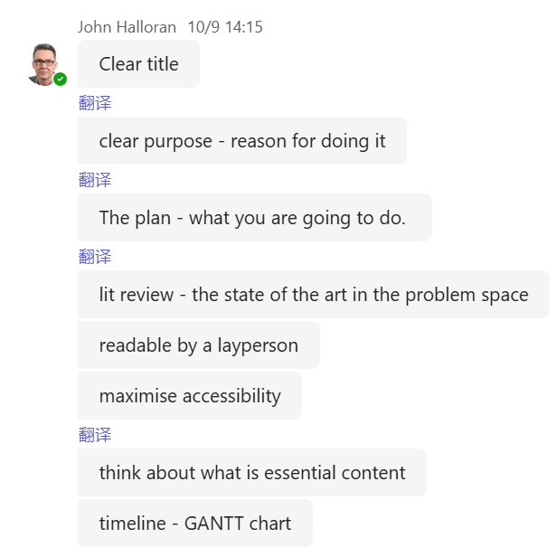

Work shown
the presentation by my supervisor, John Halloran
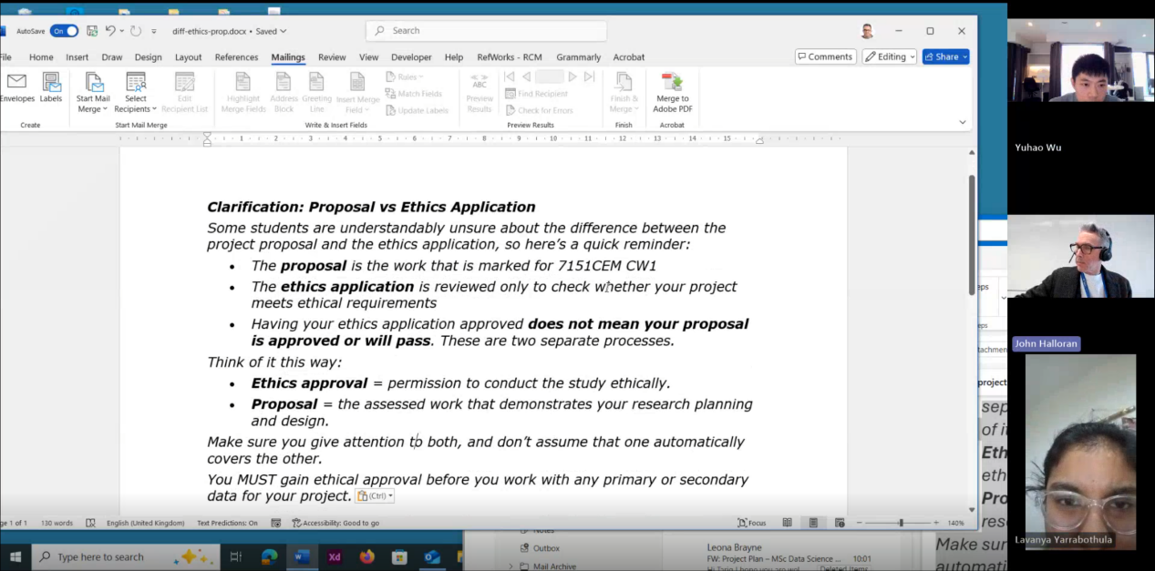

Questions asked; how questions were answered
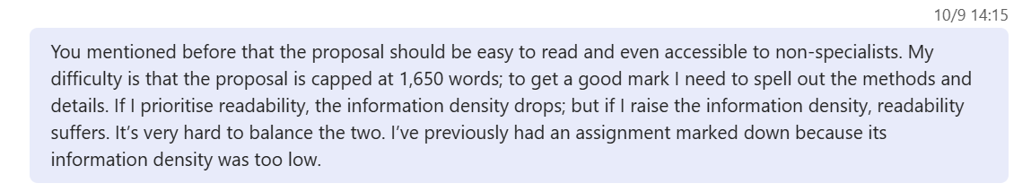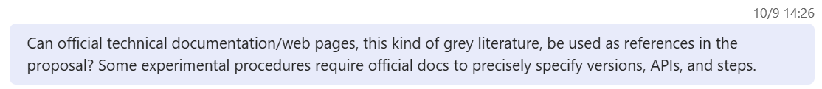
Answer
- It really is a trade-off between readability and information density. All professional researchers have to maximise the accessibility of their work, but it is precisely because this is a Master’s-level assignment that it becomes challenging.
- It can be used, but not too much. Peer review means that experts help to check and safeguard the quality of each other’s work; therefore, papers in academic journals are particularly important.
The value of grey literature lies in the fact that it often raises important issues earlier and can inspire research questions.

Email

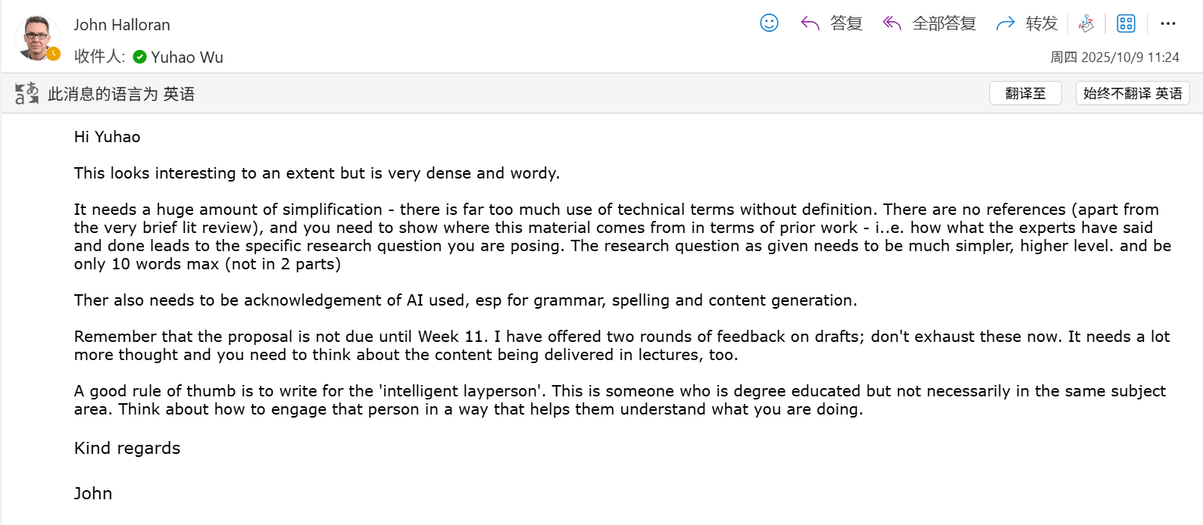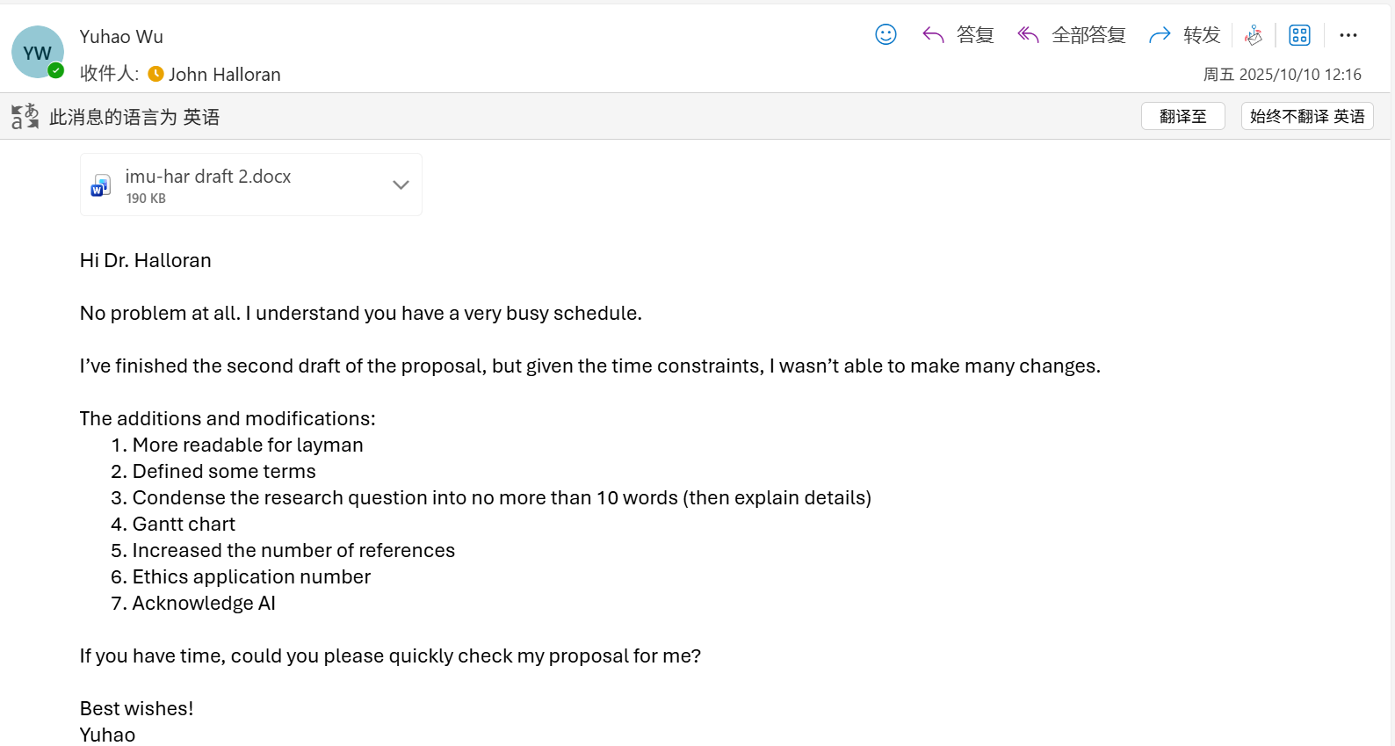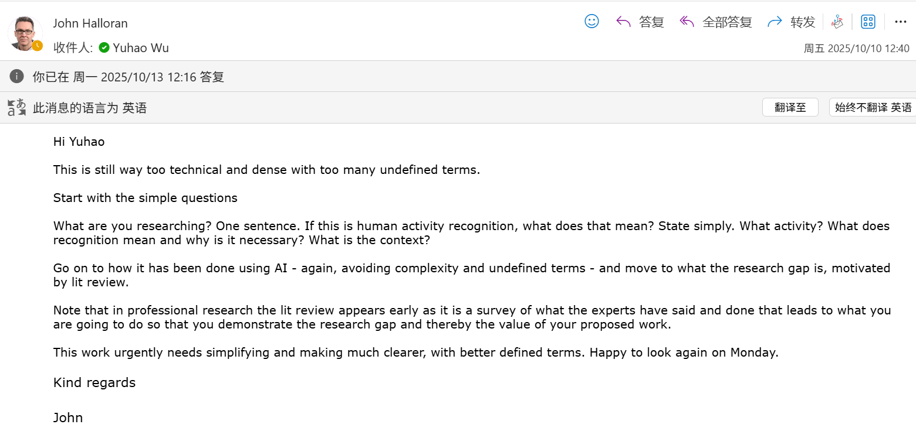

Computing Project
WORK DONE
1. Completed all preprocessing for the RealWorld dataset.
2. Revised the proposal under the guidance of my supervisor, Halloran.
3. Looked for alternative datasets that are not from Kaggle or the UCI Machine Learning Repository (LaRa Dataset).

Issues and challenges
- The proposal is still too dense, and its readability is not high enough.
- The newly selected dataset should not overlap with the current RealWorld dataset in terms of characteristics. It should be complementary and sufficiently challenging.

Actions for next week
1. Improve the readability of the proposal by defining and explaining key terms.
2. Train and test several baseline models on the fully preprocessed RealWorld dataset to see the results.

Link to recording
https://livecoventryac-my.sharepoint.com/:v:/g/personal/aa1910_coventry_ac_uk/EVjgsFUPBQZJnPAw5G4eWGAB-TAN7NLLjgToTqWwDAIsnw

Backup link (in case the original link expires)
Part 1
https://livecoventryac-my.sharepoint.com/:v:/g/personal/wuy176_uni_coventry_ac_uk/Ecf83zfoTZxIghETjmGzrigB7qqzLXU-1EreJyHyeY9ojw?e=9OM2Hu&nav=eyJyZWZlcnJhbEluZm8iOnsicmVmZXJyYWxBcHAiOiJTdHJlYW1XZWJBcHAiLCJyZWZlcnJhbFZpZXciOiJTaGFyZURpYWxvZy1MaW5rIiwicmVmZXJyYWxBcHBQbGF0Zm9ybSI6IldlYiIsInJlZmVycmFsTW9kZSI6InZpZXcifX0%3D

Part 2
https://livecoventryac-my.sharepoint.com/:v:/g/personal/wuy176_uni_coventry_ac_uk/ET0Ffy3wAg5FoigaiJZDp_wBv6oOE2N7DIrJ_vhfgLvGWw?e=oUuTrq&nav=eyJyZWZlcnJhbEluZm8iOnsicmVmZXJyYWxBcHAiOiJTdHJlYW1XZWJBcHAiLCJyZWZlcnJhbFZpZXciOiJTaGFyZURpYWxvZy1MaW5rIiwicmVmZXJyYWxBcHBQbGF0Zm9ybSI6IldlYiIsInJlZmVycmFsTW9kZSI6InZpZXcifX0%3D

